鼠标放置整条信息会动一下那种

http://c72.haiyang3.com/product/html/?201.html
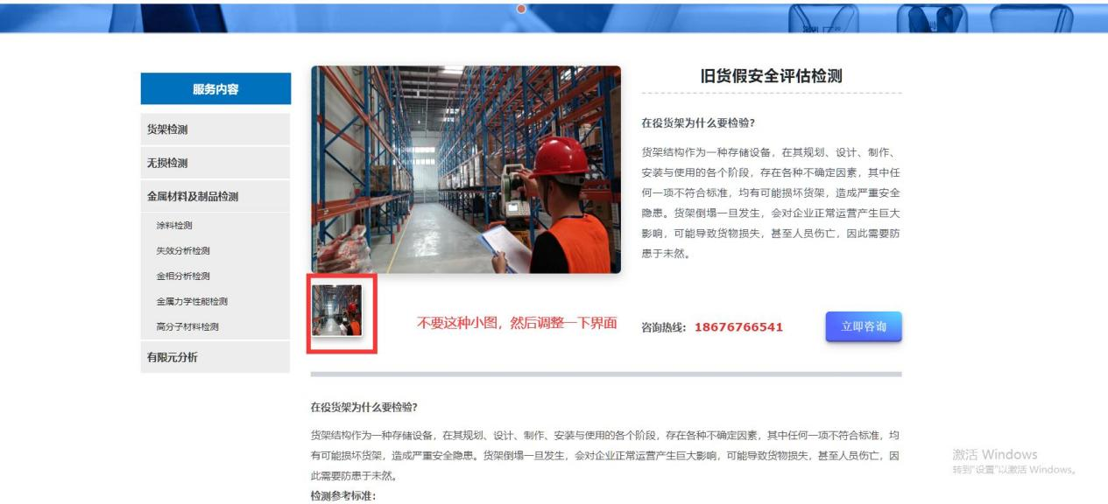

http://c72.haiyang3.com/photo/html/?44.html